**Notice for AIQ Admission Student**

**To all the students taken admission in post graduate (PG) course through All India quota**

**You need to submit original &self-attested photocopy of following documents:**

(1) Provisional allotment letter

(2) Admit card issued by NBE NEET-PG-2020

(3) Result (Rank letter) issued by NBE NEET-PG-2020

(4) Mark sheets of MBBS 1st, 2nd, 3rd professional examination

(5) MBBS degree certificate/Provisional degree

(6) Internship completion certificate

(7) Permanent/provisional registration certificate issued by MCI or State Medical Council of India

(8) School leaving certificate/birth date certificate

(9) Aadhar card copy

(10) Caste certificate (if applicable)

(11)Physically handicap certificate (if applicable)

While reporting after first round you need to pay only 10% of tuition fee (non refundable) i.e For degree course Rs.3000 and for diploma Course Rs. 2000 or account section. As on today there is no bond from Government of Gujarat

Details of other fee to be submitted after second round of counseling 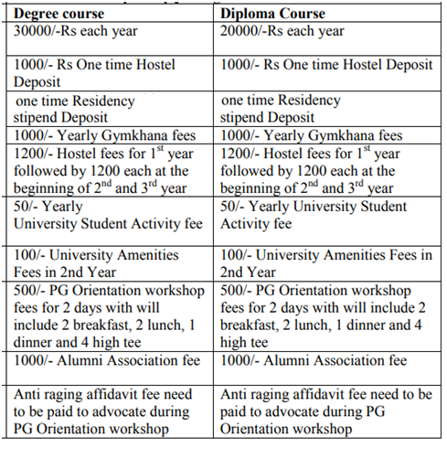

**Please follow covid appropriate behavior**

1. Please inform your travel plan, well in advance at dean.health.bhavnagar@gmail.com
2. Reach to Medical College first, which is near S.T. Bus station and opposite to Fatima convent school.
3. You must be wearing mask all the time during travel and also on campus.
4. You will be screened at college entrance. You must have Arogyasetu app downloaded in your mobile and your Covid 19 status must be updated on daily basis. You must show your ArogyaSetu status at the Time of entry into college campus
5. You are advised not to venture out of campus, and must take food in hostel canteen. You are also
6. Advised to maintain social distancing even on campus, be it a canteen, hospital or hostel